HomeWork 4

Wenyuan Shao

1. b) The compression ratio of scalar 1.33 gives the compression ratio 10.0464. In this case, the SNR is 22.8234. The inversed image is:

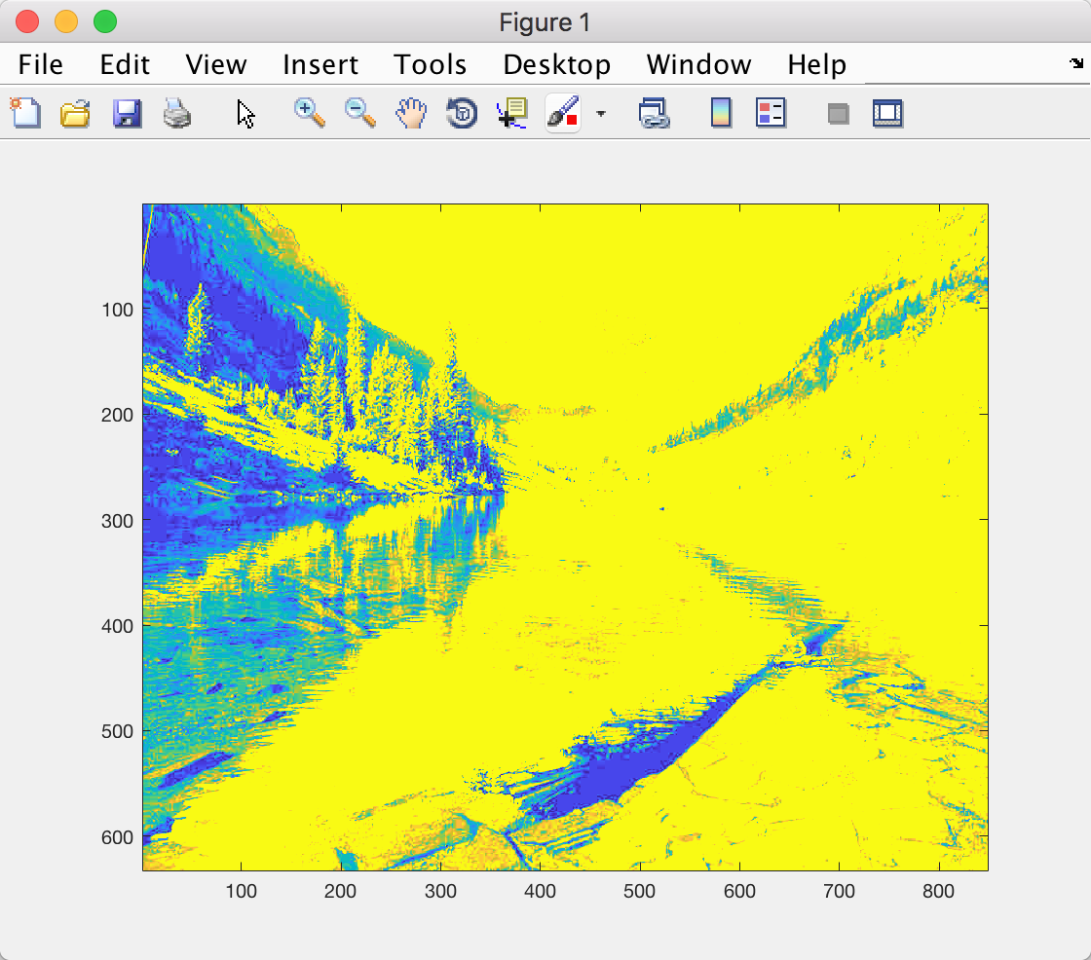

The compression ratio of scalar 2.27 gives the compression ratio 15.0795. In this case, the SNR is 21.3789. The inversed image is:

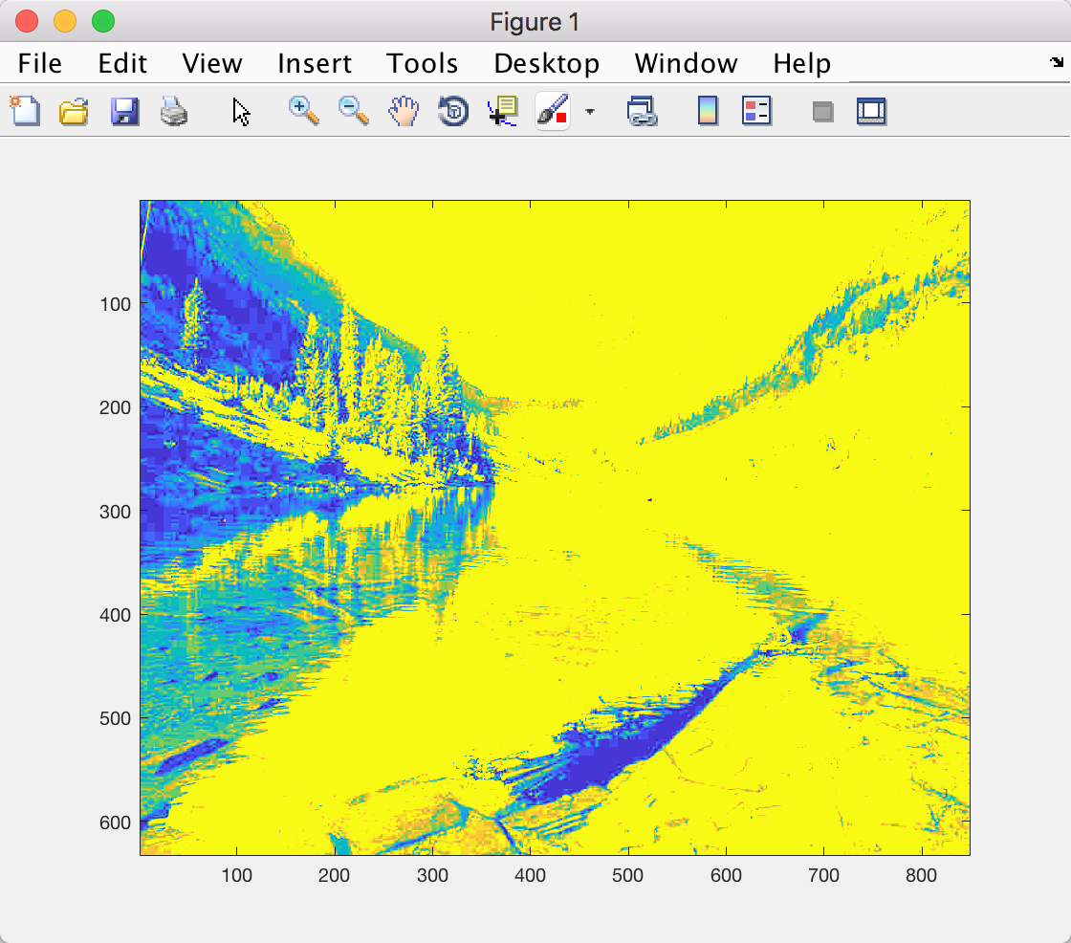

The compression ratio of scalar 3.18 gives the compression ratio 20.0083. In this case, the SNR is 20.4559. The inversed image is:

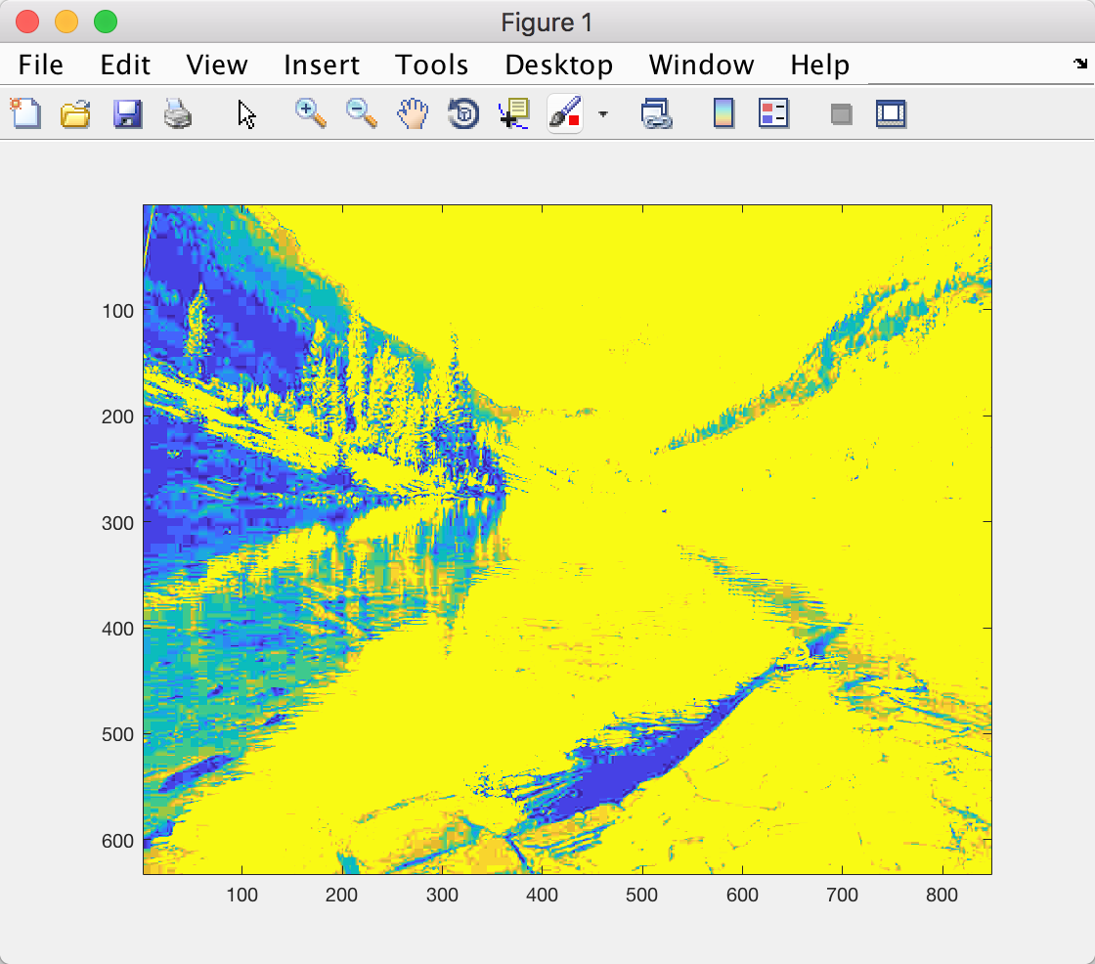

1. The plot of scale and compression ratio is like following:

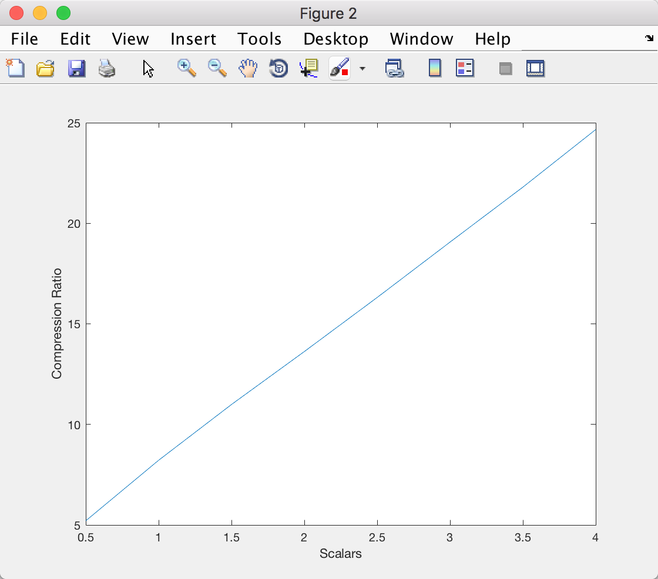

The plot of scale and SNR is like following: 